**DSP project**

Names:

Mariam Mokhtar 202000396

Mahmoud Thabet 202000328

Nasrah Mohamed 202000925

Omar Morgan 202001207

Filter design:

Filter design problem:

We are trying to design a filter to separate the signals from each other as in a real world scenario there are multiple IOT devices connected at the same time so we are trying to separate them into separate signals once again at the receiver so that the reciver can determine what action to do next with information give to it by the IOT device.

According to the standard 180 KHz is the signal bandwidth and the next signal starts at 200 KHz and so on

Thus we need to make the passband at 180 KHz and the stopband 200 KHz we have the transaiton region at 10kHz since we divide by 2.

The ripples preferably not exceed 3db and by maximum 6db, Moreover the coefficient must not go beyond 256 coefficient as according to our system it has a maximum of 256 memory elements, stopband attenuation should be -23db as this the max value that could be sent through the whole signal so anything more will only remove the noise but not the neighboring signal thus for our problem we could set this to be the desired stopband if it is more than this it is also fine,

Filters we made:

**Equiripple 256 coefficients**

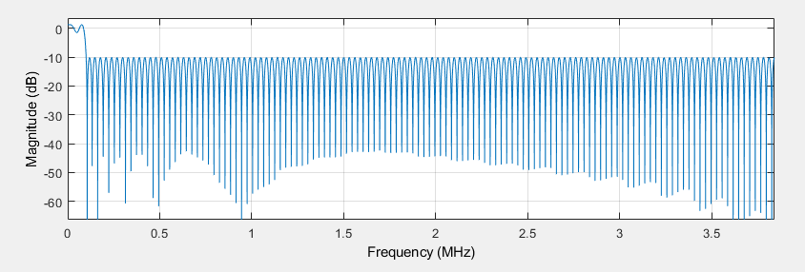

This design didn’t make the cut (pun intended) because the attenuation was lower than what we wanted

**Hamming 256**

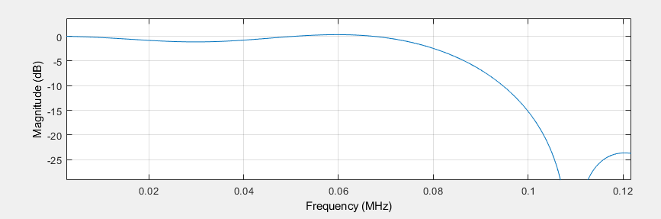

This design meets most of the specifications so we could use it but some filter out there exists that is better than this

**Taylor 256:**

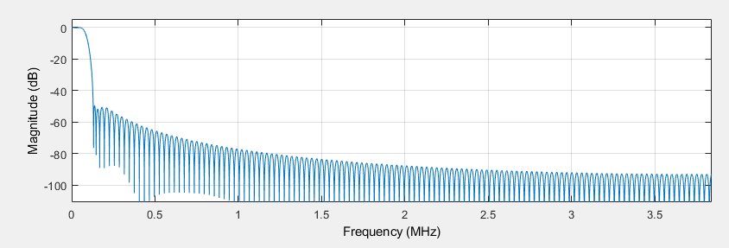

Zoomed:

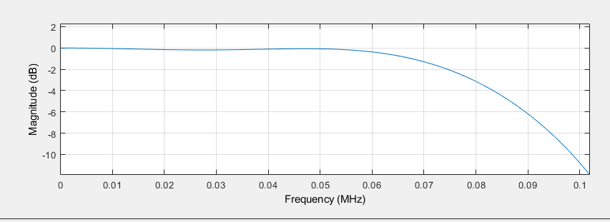

This filter meets all of the specification and is below the number of coefficients that we set as a constraint for our problem

Stopband attenuation: -50db

Passband ripples: 6 db

Transition region: is 10000 Khz

**Hamming 250:**

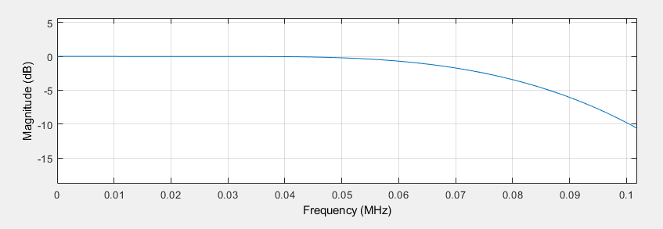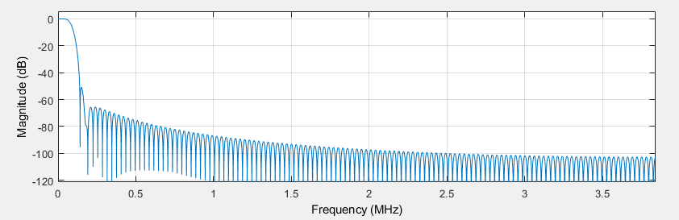

This filter is very great the passband ripples were 6db, stopband attenuation: -50db transation region 10kHz

**Least Square 256:**

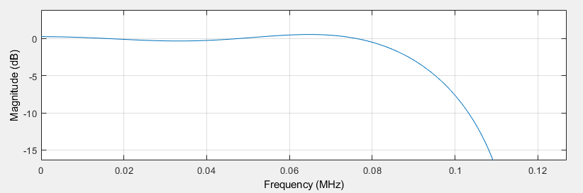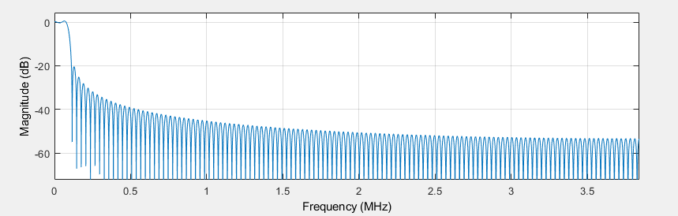

This filter wasn’t bad but other methods obtained above had better filters thus this one was not used as it has more ripples and the attenuation is lower

**Kaiser 256**:

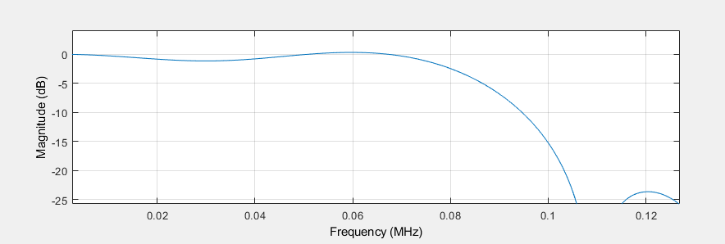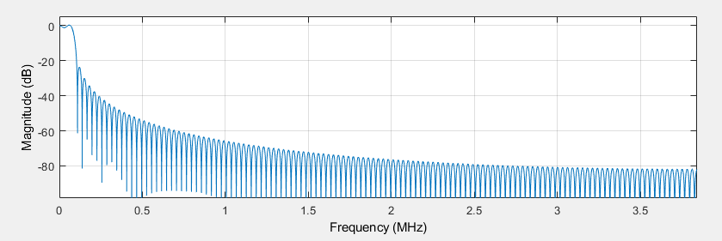

This one has larger ripples and the attenuation is not better thus it was also not used.